Ship Energy Efficiency Management Plan (SEEMP)

(Part III - Ship Operational Carbon Intensity Plan)

SHIP MANAGEMENT

Name of vessel
IMO NO.
This is reviewed & found in accordance with Reg.26.3.1 & MEPC 385(81) of MARPOL Annex VI

MT IMO NO. 10.02.2025

Explanatory notes

The SEEMP Part III has been developed in accordance with the standards described in MARPOL Annex VI, Chapter 4: Regulations on the Carbon Intensity of International Shipping, Regulations 26.3.1.

The purpose of the plan is to develop a ship-specific method to calculate the ship’s attained annual operational CII, processes used to report this value to the ship’s administration, the required annual operational CII, an implementation plan documenting how the required annual operational CII will be achieved over the next three years and a procedure for self-evaluation and improvement required by Regulation 26.3.1 of MARPOL Annex VI.

Pursuant to Regulation 5.4.6 of MARPOL Annex VI, the Administration shall ensure that the ship’s SEEMP complies with Regulation 26.3.1 of MARPOL Annex VI and MEPC.385 (81) prior to collecting any data.

MT IMO NO. 10.02.2025
Contents
- REVIEW AND UPDATE LOG 4
- SHIP PARTICULAR AND CII 5
- CALCULATION METHODOLOGY OF CII 6
- THREE-YEAR IMPLEMENTATION PLAN 8
- SELF-EVALUATION AND IMPROVEMENT 15
- PLAN OF CORRECTIVE ACTIONS(IF APPLICABLE) 16
APPENDIXⅠ. STANDARDIZED DATA REPORTING FORMAT 18
APPENDIX Ⅱ. VOYAGE ADJUSTMENT OR CORRECTION FACTORS 20
APPENDIX Ⅲ. SAMPLE OF SELF-EVALUATION AND IMPROVEMENT(IF APPLICABLE) 23

 |  | SHIP OPERATIONAL CARBON INTENSITY PLAN |  |  |  | Rev. 00
 |  | MT IMO NO. |  |  |  | 10.02.2025
1. Review and update log
 | Date/timeline |  | Updated parts | Developed by | Implemented by
 |  |  | Initial establishment |  | On-board: Master, Chief Engineer and Crew  On-shore:
OWNER/MANAGEMENT NAME SHIP MANAGEMENT 4 PAGE

 |  | SHIP OPERATIONAL CARBON INTENSITY PLAN |  |  |  |  |  |  | Rev. 00
 |  | MT IMO NO. |  |  |  |  |  |  | 10.02.2025
2. Ship Particular and CII
 | Name of the ship |  |  |  | IMO number
 | Company |  | SHIP  MANAGEMENT |  | Year of delivery
 | Flag |  |  |  | Ship type |  | TANKER
 | Gross tonnage |  |  |  | DWT
 | Applicable CII |  | ☒ AER |  | - cgDIST
 | Year |  | Required Annual  Operational CII | Attained annual Operational CII  SAMPLE  (before any  Correction) |  | Attained Annual Operational CII |  | Operational carbon intensity rating (A,B,C,D  or E):
 | 2022 |  | 6.815 | N/A |  | N/A |  | N/A
 | 2023 |  | 6.675 | 7.738 |  | 7.738 |  | D
 | 2024 |  | 6.534 | Under Process |  | Under Process
Required Annual
Operational CII
 | 2025 |  | 6.394
 | 2026 |  | 6.253
 | 2027 |  | 6.060
OWNER/MANAGEMENT NAME SHIP MANAGEMENT 5 PAGE

MT IMO NO. 10.02.2025

Calculation Methodology of CII

Description
This part describes the calculation methodology of the ship’s attained annual CII, including required data and how to obtain these data as far as not addressed in SEEMP Part II.

Calculation methodology of the Ship’s attained annual CII
    - The attained annual operational CII of individual ships is calculated as the ratio of the total mass of CO2(𝐹𝐶_{𝑗} × 𝐶_{𝐹}𝑗) emitted to the total transport work(𝐶 × 𝐷_{𝑡}) undertaken in a given
calendar year, as follows:

    - 𝑗 is the fuel oil type;

𝑎𝑡𝑡𝑎𝑖𝑛𝑒𝑑 𝐶𝐼𝐼𝑠ℎ𝑖𝑝 =
∑(𝐹𝐶𝑗 × 𝐶𝐹𝑗)

𝐶 × 𝐷𝑡

    - 𝐹𝐶𝑗 is the total mass (in grams) of consumed fuel oil type 𝑗 in the calendar year, as reported under IMO DCS;

- 𝐶𝐹
𝑗
represents the fuel oil mass to CO2 mass conversion factor for fuel oil type 𝑗, in line with

those specified in the 2018 Guidelines on the method of calculation of the attained EEDI for new ships(resolution MEPC.308(73);
    - 𝐶 represents the ship’s capacity:
For bulk carriers, container ships, Gas carriers, LNG carriers, General cargo ships, refrigerated cargo carrier and combination carriers, deadweight tonnage(DWT) should be used as Capacity;
For cruise passenger ships, ro-ro cargo ships (vehicle carriers), ro-ro cargo ships and ro-ro passenger ships, gross tonnage(GT) should be used as Capacity;

    - 𝐷𝑡 represents the total distance travelled (in nautical miles), as reported under IMO DCS

Correction Factors and Voyage Adjustments for CII Calculations
    - Use of voyage adjustments and correction factors require changes to be made to the overall attained annual operational CII(𝐶𝐼𝐼𝑠ℎ𝑖𝑝) formula as follows:

𝐶𝐼𝐼𝑠ℎ𝑖𝑝 =
∑𝑗 𝐶𝐹𝑗 ∙ {𝐹𝐶𝑗 − (𝐹𝐶𝑣𝑜𝑦𝑎𝑔𝑒,𝑗 + 𝑇𝐹𝑗 + (0.75 − 0.03𝑦𝑖) ∙ (𝐹𝐶𝑒𝑙𝑒𝑐𝑡𝑟𝑖𝑐𝑎𝑙,𝑗 + 𝐹𝐶𝑏𝑜𝑖𝑙𝑒𝑟,𝑗 + 𝐹𝐶𝑜𝑡ℎ𝑒𝑟𝑠,𝑗 ))}

𝑓 ∙ 𝑓 ∙ 𝑓 ∙ 𝑓 ∙ 𝐶𝑎𝑝𝑎𝑐𝑖𝑡𝑦 ∙ (𝐷 − 𝐷 ) ∙ 𝐴𝐹

𝑖 𝑚 𝑐
𝑖𝑉𝑆𝐸
𝑡 𝑥
𝑃𝑇

MT IMO NO. 10.02.2025

    - Corrections factors for electrical related fuel consumption 𝐹𝐶𝑒𝑙𝑒𝑐𝑡𝑟𝑖𝑐𝑎𝑙 , boiler consumption
𝐹𝐶𝑏𝑜𝑖𝑙𝑒𝑟, and other related fuel consumption 𝐹𝐶𝑜𝑡ℎ𝑒𝑟𝑠 should not be used for periods where voyage adjustments apply.
    - The correction factors should be applied according to Appendix Ⅱ.

Trial CII Calculations
    - The following metrics can be used for trial purposes, where applicable:
      - Energy Efficiency Performance Indicator(EEPI)
EEPI = 𝑀
𝐶×𝐷𝑙

      - cbDIST
cbDIST = 𝑀
𝐴𝐿𝐵×𝐷𝑡

      - clDIST
clDIST = 𝑀
𝐿𝑎𝑛𝑒𝑚𝑒𝑡𝑒𝑟×𝐷𝑡

      - EEOI, as defined in MEPC.1/Circ.684 on Guidelines for voluntary use of the ship energy efficiency operational indicator (EEOI).
    - In the formulas above:
- The mass of CO² (M), the shipʹs capacity (C) and the total distance travelled (Dt) are identical with those used to calculate the attained CII of individual ships.
- Dl means the laden distance travelled (in nautical miles) when the ship is loaded;

- ALB means the number of available lower berths of a cruise passenger ship; and

- Lanemeter means the length (in metres) of the lanes of a ro-ro ship.

MT IMO NO. 10.02.2025

Three-year Implementation Plan

Description
    - The list of measures has been considered and will be implemented to achieve the required annual CII over the next 3 years.
    - The timeline and method of the implementation plan were established and the responsible personnel of the company was designated for each planned task.

    - Possible impediments were found when the listed measures are implemented; and the possible contingency measures were made up to overcome these impediments.
    - The documentation was attached to support the substantiality of the described measures, including the simulation result of the ship’s expected CII calculation.

MT IMO NO. 10.02.2025

List of measures to be considered and implemented: -
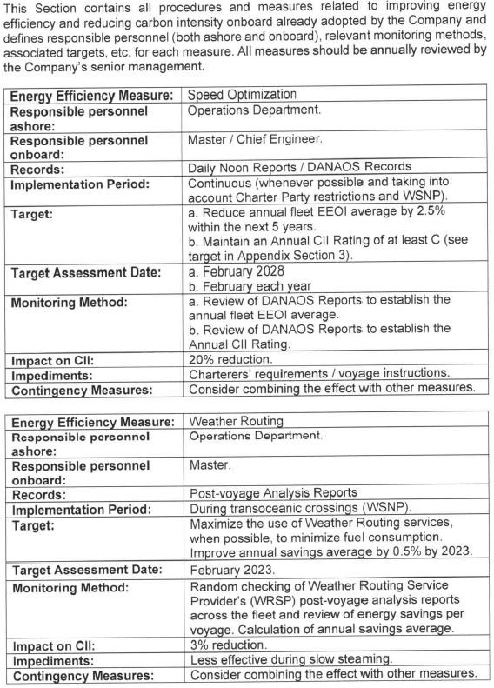

MT IMO NO. 10.02.2025
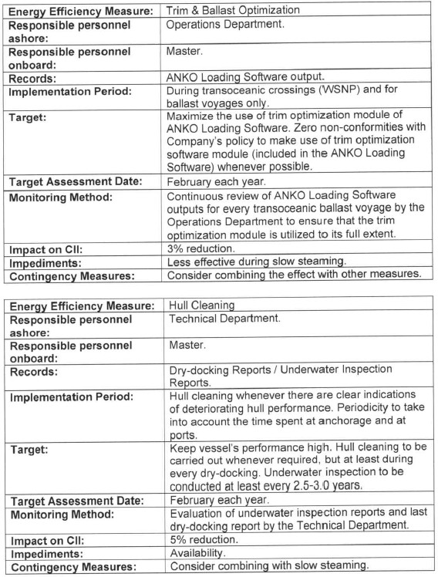

MT IMO NO. 10.02.2025
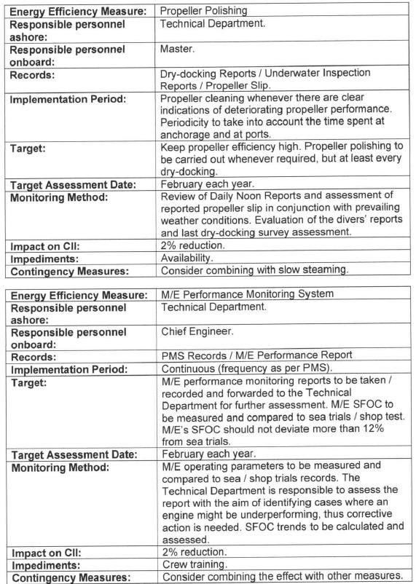

MT IMO NO. 10.02.2025
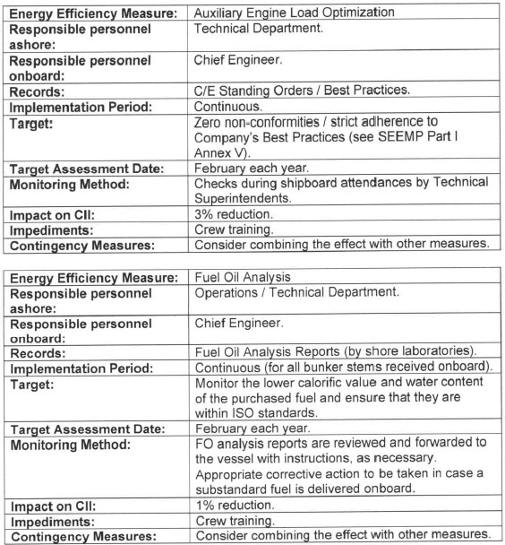

MT IMO NO. 10.02.2025
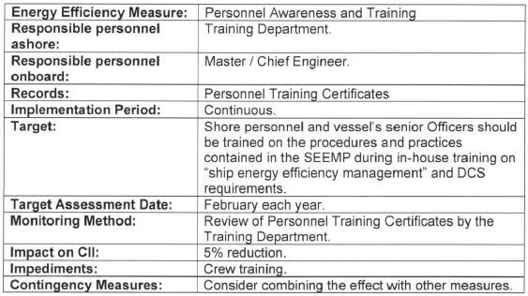
Company personnel to be responsible for the three-year implementation plan, monitoring and recording performance.

The company personnel responsible for the monitoring and recording the performance are as follows:

Effect of the measures
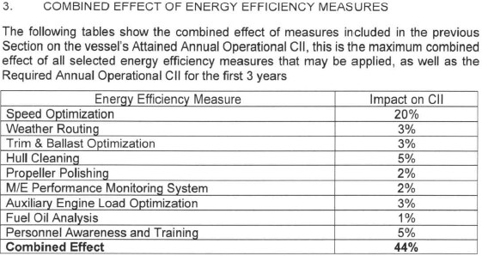

MT IMO NO. 10.02.2025

    - Calculation showing the combined effect of the measures and that the required operational CII will be achieved.
Year
Targeted rating
2025
2026
2027
C C
C
Required annual operational CII
6.394
6.253
6.060
Targeted operational annual CII
6.442
6.320
6.190
SAMPLE
MT IMO NO. 9 10.02.2025

Self-evaluation and improvement

Description
    - The person charge is responsible for establishing the procedures and methods of the self-
evaluation for evaluating the effectiveness of the measures aimed to achieve required annual operational CII at the planned milestone, and for supplementing and improving it.
    - The company better understand the overall characteristics of a ship by identifying the effectiveness and cause of measures through self-evaluation. In addition, it is possible to establish an improved management plan that can provide opportunities for energy efficiency and carbon emission reduction by analyzing the trend of efficiency improvement.

    - CII (AER/cgDIST) can be likely used as the quantitative performance indicator for self-
evaluation. The trial CII (EEPI, cbDIST, clDIST, EEOI) can be additionally considered, if convenient and/or beneficial for a ship. The monitoring toll should be calculated accurately according to Appendix X.
    - The self-evaluation should be implemented periodically at least ○ once a year, by using real operational data collected through monitoring.
    - In the evaluation, the effectiveness of each measure can be quantitatively calculated based
on the goal and the results of the implemented measures, and the following factors can be additionally reviewed for a deepen understanding:
- timeline for starting the review process

- measures to address deficiencies and discrepancies

- where relevant, actions that will be taken to bring the ship back into better CII ratings

- where relevant identification if an action plan is required and identification of critical factors that contributed to missing the CII target
    - All records related to the implementation for self-evaluation and improvement shall be documented and maintained for at least ○ 3 years on board or onshore office.

MT IMO NO. 10.02.2025

Plan of corrective actions (if applicable)

Description
    - As this ship had been rated E for 20XX or rated as D for three consecutive years, a revised SEEMP Part III was developed including a plan of corrective actions.
    - This plan of corrective actions was developed by PIC at ship and shore after discussing the followings:

      - Analysis of the cause for the inferior CII rating

      - Analysis of the performance of implemented measures

      - List of additional measures and revised measures to be add to the implementation plan

      - Work carried out by the company responsible person for the added and revised measures in the implementation plan
      - Possible impediments to the effectiveness of the measures for improving CII of the ship, including possible additional contingency measures
    - All measures had been evaluated whether Specific, Measurable, Achievable, Realistic and Time bound and were enough to be actually implemented.
    - The implementation of the plan of corrective actions would be monitored monthly basis and
the additional measure will be considered to strengthen corrective actions in case of insufficient improvements for CII.

Analysis of causes for inferior CII rating
Cause
Analysis of effect
Actions
…
…
…

MT IMO NO. 10.02.2025

Analysis of measures in the implementation plan

Measure | Analysis of effect | Actions
… | … | …

  - List of additional measures and revised measures to be added to the implementation plan

Measure | Impact on CII | Time and method of implementation and responsible personnel |  |  | Impediments and contingency measures
 |  | Milestone | Due | PIC | Impediment | Contingencies
 |  | Milestone | Due | PIC | Impediment | Contingencies
… | … | … |  |  | …

 |  | SHIP OPERATIONAL CARBON INTENSITY PLAN |  |  |  |  |  | Rev. 00
 |  | MT IMO NO. |  |  |  |  |  | 10.02.2025
AppendixⅠ. STANDARDIZED DATA REPORTING FORMAT

<STANDARDIZED DATA REPORTING FORMAT FOR THE DATA COLLECTION SYSTEM AND OPERATIONAL CARBON INTENSITY TO THE ADMINISTRATION>
 | Name of the ship |  |  |  | IMO number
 | Company |  |  |  | Year of delivery
 | Flag |  |  |  | Ship type
 | Gross tonnage |  |  |  | DWT
 | Applicable CII ☒ AER |  |  |  | - cgDIST
 | CII for trial purpose(non, one or more on  voluntary basis) |  |  |  | ☒ EEPI ☐ cbDIST ☐ clDIST ☐ EEOI
Attained annual operational CII before any correction factors
(AER in g CO₂/dwt. nm or cgDIST in g CO₂/gt.nm)
Attained annual operational CII
(AER in g CO₂/dwt. nm or cgDIST in g CO₂/gt.nm)
 | End date for annual CII (dd/mm/yy) *
 | Start date for annual CII (dd/mm/yy) *
 | Attained EEDI (if applicable)
 | Attained EEXI (if applicable)
 | EEPI (gCO2/dwt.nm)
 | cbDIST (gCO2/berth.nm)
 | cbDIST (gCO2/m.nm)
 | EEOI (gCO2/t.nm or others)
 | Method used to measure fuel oil consumption
 | Fuel oil consumption (t) |  |  | (Cf ;..)
 |  |  |  | Other ( )
 |  |  |  | Ethanol (Cf: 1.913)
 |  |  |  | Methanol (Cf: 1.375)
 |  |  |  | LNG (Cf: 2.750)
OWNER/MANAGEMENT NAME SHIP MANAGEMENT 18 PAGE

 |  | SHIP OPERATIONAL CARBON INTENSITY PLAN |  |  | Rev. 00
 |  | MT IMO NO. |  |  | 10.02.2025
 |  |  | LPG (Butane) (Cf: 3.030)
 |  |  | LPG (Propane) (Cf: 3.000)
 |  |  | HFO (Cf: 3.114)
 |  |  | LFO (Cf: 3.151)
 |  |  | Diesel/Gas Oil (Cf: 3.206)
 | Hours underway (h)
 | Distance Travelled (nm)
 | Power output (rated power) (kW) |  | Main Propulsion Power
 |  |  | Auxiliary Engine(s)
 | Ice class (if applicable)
 | DWT
 | NT
 | Gross Tonnage
 | Ship type
 | IMO number
 | End date for DCS (dd/mm/yy)
 | Start date for DCS (dd/mm/yy)
OWNER/MANAGEMENT NAME SHIP MANAGEMENT 19 PAGE

 |  | SHIP OPERATIONAL CARBON INTENSITY PLAN |  |  |  | Rev. 00
Appendix Ⅱ. Voyage Adjustment or Correction Factors

This table is based on RESOLUTION MEPC.355(78).
 | Correction  factor |  | Description | Additional equation | Remark
 | 𝑗 |  | the fuel type
 | 𝐶𝐹𝑗 |  | the fuel mass to CO2 mass conversion factor for fuel type 𝑗 , in line with those specified in resolution MEPC.308(73)
 | 𝐹𝐶𝑗 |  | the total mass of consumed fuel of type 𝑗 in the calendar year, as reported under IMO DCS, converted to grams
 | 𝐹𝐶𝑣𝑜𝑦𝑎𝑔𝑒,𝑗 |  | the mass of fuel of type 𝑗, consumed in voyage periods during the calendar year which may be deducted from the calculation of the attained CII in case the  ship encounters one of the following situations: | In cases where 𝐹𝐶𝑣𝑜𝑦𝑎𝑔𝑒,𝑗 is used  - Any associated distance travelled must also be deducted using 𝐷𝑥;  - The ship should report data for the  deductions associated with voyage adjustments to the Administration. | scenarios specified in regulation 3.1 of MARPOL  Annex VI, which may endanger safe navigation of a ship
 |  |  |  |  | sailing in ice conditions, which means sailing of an ice- classed ship in a sea area within the ice edge.
 | 𝑇𝐹𝑗 |  | the quantity of fuel 𝑗 removed for STS or shuttle tanker operation:  𝑇𝐹𝑗 = (1 − 𝐴𝐹𝑇𝑎𝑛𝑘𝑒𝑟) ∙ 𝐹𝐶𝑆,𝑗 |  | where 𝐹𝐶𝑆,𝑗 = 𝐹𝐶𝑗 for shuttle tankers and 𝐹𝐶𝑆,𝑗 is total quantity of fuel 𝑗 used on STS voyages for STS vessels.  If 𝑇𝐹𝑗 > 0 then 𝐹𝐶𝑒𝑙𝑒𝑐𝑡𝑟𝑖𝑐𝑎𝑙,𝑗 = 𝐹𝐶𝑏𝑜𝑖𝑙𝑒𝑟,𝑗 = 𝐹𝐶𝑜𝑡ℎ𝑒𝑟𝑠,𝑗 = 0;
 | 𝑦𝑖 |  | consecutive numbering system starting at  𝑦2023 = 0, 𝑦2024 = 1, 𝑦2025 = 2, etc;
 | 𝑓𝑖 |  | the capacity correction factor for ice- classed ships |  | EEDI correction factors can be applied provided they are included in ship’s EEDI Technical file or EEXI  Technical File.
 | 𝑓𝑚 |  | the factor for ice-classed ships having IA Super and IA |  | EEDI correction factors can be applied provided they are included in ship’s EEDI Technical file or EEXI Technical File.
OWNER/MANAGEMENT NAME 20 PAGE

 |  | SHIP OPERATIONAL CARBON INTENSITY PLAN |  |  |  |  | Rev. 00
 | 𝑓𝑐 |  | the cubic capacity correction factors for chemical tankers |  |  | EEDI correction factors can be applied provided they are included in ship’s EEDI Technical file or EEXI Technical File.
 | 𝑓𝑖𝑉𝑆𝐸 |  | the correction factor for ship specific voluntary structural enhancement |  |  | EEDI correction factors can be applied provided they are included in ship’s EEDI Technical file or EEXI Technical File.
 | 𝐶𝑎𝑝𝑎𝑐𝑖𝑡𝑦 |  | deadweight or gross tonnes as defined for each specific ship type in CII Reference Lines Guidelines(G2)
 | 𝐷𝑡 |  | the total distance travelled, as reported under IMO DCS
 | 𝐷𝑥 |  | distance travelled for specific voyage  (𝐹𝐶𝑣𝑜𝑦𝑎𝑔𝑒,𝑗 )
 | 𝐴𝐹𝑇𝑎𝑛𝑘𝑒𝑟 |  | STS(ship to ship) transfer operation |  | 𝐴𝐹𝑇𝑎𝑛𝑘𝑒𝑟,𝑆𝑇𝑆 = 6.1742 × 𝐷𝑊𝑇−0.246 | Where 𝐴𝐹𝑇𝑎𝑛𝑘𝑒𝑟,𝑆𝑇𝑆 is applied, 𝐹𝐶𝑒𝑙𝑒𝑡𝑟𝑖𝑐𝑎𝑙, 𝐹𝐶𝑏𝑜𝑖𝑙𝑒𝑟 and  𝐹𝐶𝑜𝑡ℎ𝑒𝑟𝑠 should not be used.
 |  |  | Shuttle tankers |  | 𝐴𝐹𝑇𝑎𝑛𝑘𝑒𝑟,𝑆ℎ𝑢𝑡𝑡𝑙𝑒 = 5.6805 × 𝐷𝑊𝑇−0.208 | Where 𝐴𝐹𝑇𝑎𝑛𝑘𝑒𝑟,𝑆ℎ𝑢𝑡𝑡𝑙𝑒 is applied,  𝐹𝐶𝑒𝑙𝑒𝑡𝑟𝑖𝑐𝑎𝑙, 𝐹𝐶𝑏𝑜𝑖𝑙𝑒𝑟, 𝐹𝐶𝑜𝑡ℎ𝑒𝑟𝑠 and 𝐴𝐹𝑇𝑎𝑛𝑘𝑒𝑟,𝑆𝑇𝑆 should not be used.
 | 𝐹𝐶𝑒𝑙𝑒𝑐𝑡𝑟𝑖𝑐𝑎𝑙 |  | Estimated fuel consumptio n attributed to in use refrigerated Containers | have the ability to monitor reefer electrical consumption | 𝐹𝐶𝑒𝑙𝑒𝑡𝑟𝑖𝑐𝑎𝑙𝑟𝑒𝑒𝑓𝑒𝑟,𝑗 = 𝑅𝑒𝑒𝑓𝑒𝑟 𝑘𝑊ℎ × 𝑆𝐹𝑂𝐶 | - SFOC is fuel consumption in g/kWh as a weighted average of the engines used to provide the electrical power as per the EEDI/EEXI Technical file or the NOx Technical file.
 |  |  |  | do not have the ability to monitor reefer electrical consumption | 𝐹𝐶𝑒𝑙𝑒𝑡𝑟𝑖𝑐𝑎𝑙𝑟𝑒𝑒𝑓𝑒𝑟,𝑗 = 𝐶𝑥 ∙ 24 ∙ 𝑆𝐹𝑂𝐶𝑎𝑣𝑔 ∙ (𝑅𝑒𝑒𝑓𝑒𝑟𝑑𝑎𝑦𝑠 + ∑ 𝑅𝑒𝑒𝑓𝑒𝑟𝑑𝑎𝑦𝑠 )  𝑠𝑒𝑎 𝑝𝑜𝑟𝑡 | - 𝑐𝑥 is a default reefer consumption, 2.75 kW/h  - SFOC is fuel consumption in g/kWh as a weighted  average of the engines used to provide the electrical power as per the EEDI/EEXI Technical file or the NOx Technical file.  - 𝑅𝑒𝑒𝑓𝑒𝑟𝑑𝑎𝑦𝑠𝑝𝑜𝑟𝑡 =  𝑁𝑜𝑐𝐴𝑟𝑟𝑖𝑣𝑎𝑙 + 𝑁𝑜𝑐𝐷𝑒𝑝𝑎𝑟𝑡𝑢𝑟𝑒 × 𝐷𝑎𝑦𝑠  2 𝑝𝑜𝑟𝑡
OWNER/MANAGEMENT NAME 21 PAGE

 |  | SHIP OPERATIONAL CARBON INTENSITY PLAN |  |  |  | Rev. 00
 |  |  | Estimated fuel consumption attributed to Cargo cooling Systems on Gas carriers and LNG carriers | 𝐹𝐶𝑒𝑙𝑒𝑡𝑟𝑖𝑐𝑎𝑙𝑐𝑜𝑜𝑙𝑖𝑛𝑔,𝑗 = 𝐶𝑜𝑜𝑙𝑖𝑛𝑔 𝑘𝑊ℎ × 𝑆𝐹𝑂𝐶 | - 𝐶𝑜𝑜𝑙𝑖𝑛𝑔 𝑘𝑊ℎ is measured on the vessel by the kWh meter counter on the vessel  - SFOC is fuel consumption in g/kWh associated with the relevant source of electrical power as per the EEDI/EEXI Technical file or the NOx Technical file.
 |  |  | Electric Cargo discharge pumps on tankers | 𝐹𝐶𝑒𝑙𝑒𝑡𝑟𝑖𝑐𝑎𝑙𝑑𝑖𝑠𝑐ℎ𝑎𝑟𝑔𝑒 ,𝑗 = 𝐷𝑖𝑠𝑐ℎ𝑎𝑟𝑔𝑒 𝑘𝑊ℎ × 𝑆𝐹𝑂𝐶 | - 𝐷𝑖𝑠𝑐ℎ𝑎𝑟𝑔𝑒 𝑘𝑊ℎ is measured on the vessel by the kWh meter counter on the vessel  - SFOC is fuel consumption in g/kWh associated with the relevant source of electrical power as per the EEDI/EEXI Technical file or the NOx Technical file.
 | 𝐹𝐶𝐵𝑜𝑖𝑙𝑒𝑟,𝑗 |  | the mass of fuel of type 𝑗, consumed by  oil fired boiler for the purposes of cargo heating and cargo discharge on tankers |  | 𝐹𝐶𝐵𝑜𝑖𝑙𝑒𝑟,𝑗 should be measured by accepted means, e.g. tanks soundings, flow meters.
 | 𝐹𝐶𝑜𝑡ℎ𝑒𝑟𝑠,𝑗 |  | the mass of fuel of type 𝑗, consumed by  standalone engine driven cargo pumps during discharge operations on tankers |  | 𝐹𝐶𝑜𝑡ℎ𝑒𝑟𝑠,𝑗 should be measured by accepted means,  e.g. tanks soundings, flow meters.
 | 𝐴𝐹𝑃𝑇 |  | The port time correction factor for cruise passenger ships only | 𝐻𝑜𝑢𝑟𝑠 𝑈𝑛𝑑𝑒𝑟 𝑊𝑎𝑦  𝐴𝐹𝑃𝑇 = (1.8 − 𝐻𝑜𝑢𝑟𝑠 𝐼𝑛 𝑂𝑝𝑒𝑟𝑎𝑡𝑖𝑜𝑛) | For cruise passenger ships where  𝐻𝑜𝑢𝑟𝑠 𝑈𝑛𝑑𝑒𝑟 𝑊𝑎𝑦  ≥ 0.8, 𝐴𝐹𝑃𝑇 = 1  𝐻𝑜𝑢𝑟𝑠 𝐼𝑛 𝑂𝑝𝑒𝑟𝑎𝑡𝑖𝑜𝑛
OWNER/MANAGEMENT NAME 22 PAGE

SHIP OPERATIONAL CARBON INTENSITY PLAN Rev. 00
- Weather routing
Period | Goal | Evaluation | Difference
Final result |  |  | XX %

- Weather routing
Period | Goal | Evaluation | Difference
Final result |  |  | XX %

Measure | Impact on CII | Time and method of implementation and responsible  personnel |  |  |  |  | Impediments and contingency measures
… |  |  | Milestone | Due | Responsible |  |  | Impediments | Contingencies

“SHIP NAME” / IMO No.1000000

Appendix Ⅲ. Sample of Self-evaluation and Improvement (IF APPLICABLE)

Prepared by | Approved by
 |  | Implementation Date : 202X.XX.XX
- Performance goal and evaluation result
▶ CII

▶ Trial CII(EEOI, EEPI,…)

- Improvement

OWNER/MANAGEMENT NAME 23 PAGE

